Design proposal title [X Paper Title]
First name1 Last name1, First name2 Last name2, First name3 Last name3 LEAVE BLANK FOR INITIAL SUBMISSION
email.address1@organisation1.org, affiliation name1 LEAVE BLANK FOR INITIAL SUBMISSION
email.address2@organisation2.org, affiliation name2 LEAVE BLANK FOR INITIAL SUBMISSION
email.address3@organisation3.org, affiliation name3 LEAVE BLANK FOR INITIAL SUBMISSION
Abstract: These guidelines provide instructions to format your design proposal submission for the MinD conference 2019. Please write directly into the template or copy your finished text into it choosing ‘match destination formatting’. Please use the predefined formatting styles instead of applying your individual settings. These styles are preceded with ‘X’, such as X Paper Title, X Abstract or X Paragraph. Do not change the predefined formatting settings in this document as the aim is to produce the conference proceedings, the conference programme, and other important information, using a consistent style. The Abstract should be no more than 250 words and one paragraph only. Avoid quotation and citing references in your abstract. Submit your paper to the conference review system. [this paragraph is formatted as X Abstract]
Keywords: maximum 4 keywords; paper format; instructions; use of template [the keywords are formatted as X Keywords]

1. Introduction [this is formatted as X Heading 1]
We invite the submission of designs in analog or digital format, including e. g. physical artefacts, digital artefacts, films/video. Contributions are expected to offer new or challenging ideas, novel approaches, working methods or design interventions, or similar. Submissions will be exhibited during and as part of the conference.
In the first instance proposals should be submitted by 1 February 2019, including an image or visualisation and a verbal description of the design, and a statement of the underpinning research detailing its originality, significance and rigour.
Please structure you statement as follows:
- Introduction (describe your research and/or design problem, motivation, up to 300 words)
- Description of design proposal (describe and illustrate your architectural, product, service or other design proposal and the way it works, up to 300 words)
- Complemenary Data Description (name and describe the kind and purpose of the additional data you submit [video files etc.])
- Technical Information for Exhibition (describe the kind of digital or physical artefact, its size, connectivity needs [A/C mains etc.])
All design proposal submissions will be selected through a double blind review process conducted by an international review panel. Please read these guidelines all the way through before submission as they will save you valuable time. If English is not your first language please ensure that a fluent speaker proofreads your paper or use a proof reading service such as Scribendi (http://www.scribendi.com). [X Paragraph]
You should submit your initial design proposal description in PDF format using this template. Design proposal submissions should be 1000–2000 words in length excluding abstract and references and should be complemented by additional data such as video files or 3d PDF.
All accepted design proposal submissions will be exhibited as part of and during the MinD2019 conference. Verbal descriptions and complementing digital data will be published in the online proceedings which will have an ISSN or DOI number and be made accessible from an academic open access website. We aim to produce conference proceedings of a professional and consistent quality, and appreciate you carefully following the instructions outlined in this guide.
This template document itself uses the same formatting as required for the Conference so your submission should appear visually very similar. You can access template styles for Titles, paragraphs, and other styles directly from the Quick Style Menu that is part of the Home Menu in Word. You can either write directly into the template or paste your finished text into it and choose ‘match destination formatting’ in the pop-up menu that appears when you paste in text. Do not change the predefined formatting settings in this document (such as paper size, orientation, margins, typeface, size, indents, spacing, headings, etc.). The layouts of all accepted submissions will be merged to the proceedings layout using the same template style naming but slightly different typography.

2. How your paper will be reviewed
Peer review is central to ensuring the quality of material that is presented at the conference. Your submission will be reviewed anonymously by two people. Reviewers will be asked to provide their reviews based on rating relevance/ significance, novelty/ originality, and clarity. Authors will be informed of the outcome.

3. Completing your submission
The sections of your paper should be numbered, though not use any sub-section (i. e. Section 2.1 or Section 2.2.1 should not be used).
Tables should be formatted as Table 1 (below): left justified text for first column and centred columns thereafter, if possible. Only horizontal table grid lines should be used. Add one empty paragraph of the [X Paragraph] style following a table.
Table 1 Table layout. Captions for Tables are placed above. [X Table title].
Table Rows [X Table] | Cell one | Cell two
Second Row | 1 | 2
Third Row | 2 | 3
Fourth Row | 4 | 5

Short quotations within the text should be marked with double quotation marks: Lawson also has a broad understanding of design when he mentions: “Professional designers such as architects, fashion designers and engineers” (Lawson, 2004, p. 5). Longer quotations of more than one line should be formatted as below, again within double quotation marks:
“More of the goods and services produced for consumer across a range of sectors can be conceived of as ‘cultural’ goods, in that way they are deliberately inscribed with to generate desire for then amongst the end uses sold to consumers in terms of particular clusters of meaning indicates the increased importance of ‘culture’ to production circulation of a multitude of goods and services.” (du Gay, et al, 1997, p.24) [X Long quotation]
For lists of material you can either use a bulleted list:
- Wellbeing; [X Bullet list]
- Empowerment;
- Happiness.
Or a numbered list:
- Designing [X Numbered list]
- With and for
- People with dementia.
Referencing should follow the APA, Author-date, Style Guide that is explained on slides 13–25 of the following presentation: http://tinyurl.com/pjhs6f3.
To allow double blind peer review it is very important that you do not include authors’ names or institutional details in the review version of the paper, you can add these later if your paper is accepted.
Double blind reviewing also means that you need to anonymise any reference to your own publications. Citations of your own work in the main text should take the form (Author, 2015). References to your own work should be presented at the end of the list in the following way (this for a journal article, for example, but equally for other forms of publication): Author (2012). Journal article
Links to web addresses over 25 characters in length (either in the main text or in the references) should first be shortened using TinyURL (http://tinyurl.com) for purposes of neatness.
If you use reference management software such as EndNote or Word Citation & Bibliography make sure that you submit your paper with the fields unlinked to your bibliographical database.
Please think carefully about the presentation of any visual material. As the proceedings will be published in digital form you have the opportunity to include good quality colour images or other media files that help to present your research and its context.
Where possible please make images:
- Large enough to see clearly;
- Of good resolution (200 dpi);
- Optimised to be less than 350 kB;
- Cropped appropriately.
If you are using diagrams, info graphics, or other schematics please ensure that:
- You present information clearly;
- You use the Open Sans font
(download at google.com/fonts/specimen/Open+Sans);
- All text is legible;
After you insert an image into your document, select it and use the style named [X Picture]. Images are followed by a caption with figures numbered sequentially – Figure 1, Figure 2, etc. Please do refer to your figure numbers in the text, please do not refer using phrases such as “the following figure illustrates …” because the placement of figures may be changed during the final layout process.
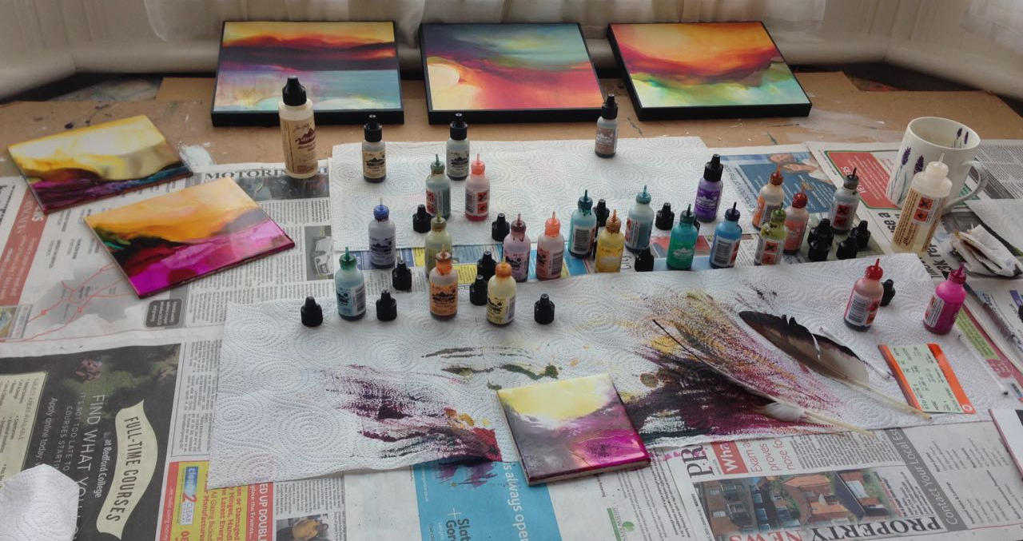
Figure 1 Captions are placed under the pictures. Ensure that your caption adequately describes what you want your reader to see in the picture, highlighting any areas that they should focus on or relationships that you might want them to see. [X Caption].

4. Submitting your design proposal
In preparing your submission for the conference please note the following:
- We are aiming to produce a high-quality conference proceedings. Please follow as closely as possible this template structure and associated style guidelines;
- Your initial submission should be in PDF format and complementing data, packed in PDF or ZIP container. Should your submission be accepted final submissions will be in PDF and Word format only to allow us to prepare the conference proceedings;
- Please register an account and submit your submission at the online conference system;
Please make sure you can answer ‘yes’ to all the following questions:
- Is the context of the work clearly described?
- Is the contribution that is made clearly stated?
- Does the submission conform to the paper template?
- Has the submission been independently proof read?
You will be prompted to tick topic area(s) that best fit your research. This will allow the MinD2019 review committee to allocate suitable reviewers to your submission.
Acknowledgements: this section is optional. You can use this section to acknowledge support you have had for your research from your colleagues, student’s participation, internal or external partners’ contribution or funding bodies. [X Acknowledgments]

5. References
Adams, R., Mann, L., Jordan, S., and Daly, S. (2009). Exploring the Boudaries: Language Roles and Structures in Cross-Disciplinatry Design teams, in McDonnell, J. and Lloyd, P. (eds.), About: Designing: Analysing Design Meeting, Taylor & Francis, pp. 339–358. [X Reference list]
du Gay, P., Hall, S., Janes, L., Mackay, H., and Negus, K. (1997). Doing Cultural Studies: The Story of the Sony Walkman, Sage.
Lawson, B. (2004). What Designers Know, Architectural Press.
Norman, D. (2010). Why Design Education Must Change, http://tinyurl.com/oaz3u6m, (Accessed 20 July, 2015).
Rancière, J. (1991). The Ignorant Schoolmaster: Five Lessons in Intellectual Emancipation, Stanford University Press.
Tovey, M., Porter, S., & Newman, R. (2003). Sketching, concept development and automotive design, Design Studies, 24, pp 135–153.
Ulrich, K., and Eppinger, S. (2004). Product Design and Development (3rd edition), McGraw-Hill/Irwin.
Author (2012). Journal article.
Author (2015). Conference paper.

